Program #2
CECS 274 - Java Programming
Due March 3, 2020

Solitaire Prime – Revised as of Feb 16, 2020

Solitaire is a card game that is played by one person. Solitaire is also known by the name “Patience”.
It is estimated that there are more than 1700 different versions of Solitaire… make that 1701 because we are inventing a new Solitaire game today.

Welcome to Solitaire Prime! This game uses one standard deck of cards. Here are the rules:

- Take the top card from the deck and place it face up on the table.
- The Sum is now the value of that card (Ace = 1, 2 = 2, … 10 = 10, Jack = 10, Queen = 10, King = 10)
- If the Sum is a prime number, discard that pile, and start over at instruction #1
- If the Sum is not prime, take the next card from the top of the deck and place it on top of the pile on the table.
- The Sum is now the sum of all cards in the pile on the table.
- Go to instruction #3.
- Play the game until all cards in the deck have been played.

Continue to play the game, keeping track of how many piles you have created that are prime.

If the last card from the deck gives you a prime pile, then you win! Write the word “Winner” on the screen and show how many prime piles there were.

If the last card from the deck does not give you a prime pile, then you lose. Write the word “Loser” in the screen.

In the main function, you will have a menu that looks like this:

Welcome to Solitaire Prime!
- New Deck
- Display Deck
- Shuffle Deck
- Play Solitaire Prime
- Exit
- Simulate 1000 games (*new requirement)

New Deck will create an unshuffled deck. (in the order: Spades, Hearts, Diamonds, Clubs… Ace, 2, 3, …, 10, Jack, Queen, King)
Display Deck will display all cards in a grid: 13 columns by 4 rows.
Shuffle Deck will randomly shuffle all cards in the deck.
Play Solitaire will play the game as described above.
Exit will exit the program.
Simulate 1000 games will show the stats of wins vs. losses in 1000 games

These 2 screen shots show possible winner and loser games. Notice that each time a card is dealt, the card is displayed and the current sum of the pile is displayed as well. When you acquire a Prime pile print out the value (prime number) and start over on the next line.

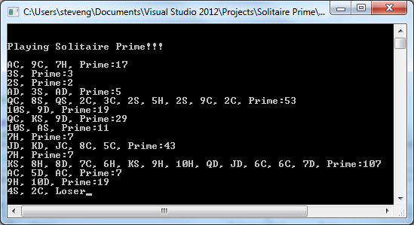

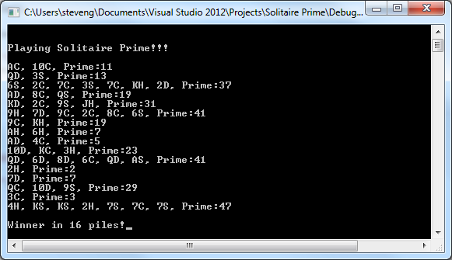

You will have 2 classes:
- The Deck class which will create the deck of cards
- The Card class which creates cards

The main logic of the program will be in the main function. You will build the following static functions in the main class:
boolean isPrime(int x); // return true if x is prime
int menu( ); // return the menu option the user typed
You will use the Card class and the Deck class to play the game.
Here is a possible outcome for option 6 – Simulate 1000 games:

Welcome to Solitaire Prime!
-----------------
1. New Deck
2. Display Deck
3. Shuffle Deck
4. Play Game
5. Exit
6. Simulate 1000 games

(When the game plays 1000 times – here are some of the results that I got)

In 1000 games, you won 379 and lost 621
In 1000 games, you won 378 and lost 622
In 1000 games, you won 369 and lost 631
In 1000 games, you won 352 and lost 648
In 1000 games, you won 393 and lost 607

Here’s the loop I used for option 6:

if (choice == 6)
{
int win = 0;
int lose = 0;
for (int i = 0; i < 1000; i++)
{
myDeck = new Deck();
myDeck.shuffle();
if (playSolitairePrime(myDeck) == true)
win++;
else
lose++;
}
System.out.println("In 1000 games, you won:"+win + " and lost:"+lose);

}
Here is a description of the classes and methods

// This is the Card class
public class Card {
private char suit;
private char rank;

public Card(char r, char s) // constructor
{
// need to complete
}

public void display()
{
// need to complete Example: Ace of Hearts = AH,
// Queen of Diamonds = QD
// Three of Clubs = 3C, Ten of Spades = 10S
}

public int getValue()
{
// need to complete
}

public char getRank() // not used for our program
{
// need to complete
}

public char getSuit() // not used for our program
{
// need to complete
}
}
// This is the Deck class
import java.util.Random; // need this for the shuffle

// I am writing the Deck constructor for you
public class Deck {
private Card [ ] storage; // make an array of cards
private int top; // top of the deck, the next card to deal

public Deck()
{
char [] suits = {‘H’, ‘D’, ‘S’, ‘C’};
char [] ranks = {‘A’, ‘2’, . . . ,’T’, ‘J’, ‘Q’, ‘K’};
storage = new Card[52];
top = 0; // the top card in the deck

int count = 0;
Card C1;
for (int s = 0; s < suits.length; s++)
for (int r = 0; r < ranks.length; r++)
{
C1 = new Card(ranks[r], suits[s]);
storage[count++] = C1;
}
}

public void display()
{
// need to complete
}

public void shuffle()
{
// need to complete – use Random()
}

public Card deal()
{
// need to complete
}

Public int cardsLeft() // how many cards are left in the deck
{
// need to complete
}

}

